

**Microcontroller Based System Design Lab**

**Final Report**

Advanced Line Follower Robot

SUBMITTED TO:

Mr. Rayhan Ahmed Ms. Afsana Ahmed Munia

LECTURER ASSISTANT PROFESSOR

SUBMITTED BY:

SHANJOY PAUL SAGOR AHAMED NABIL AHMED

15.02.04.033 15.02.04.041 15.02.04.053

**OVERVIEW**

For our project, we have decided to build a smart line follower robot. The basic function of our line follower robot is to travel through a path designed using black lines. The robot has the capability to travel through both straight and curved lines, as well as take corner turns. It also has the capability to travel through caves as well as avoid obstacles. Additional functions include sound generation upon taking turns, series of LED lights at the front of the robot and displaying presence/absence of line follower robot inside cave using LCD.

**INSTRUMENTS**

1. Robot Car Chassis

2. Arduino Mega 2560 Rev3 & Arduino Uno

3. L293D Dual DC Motor Controller

4. Digital IR Sensor Array6B (TCRT5000)

5. Battery Packs Lithium Ion Battery

6. Ball Caster

7. Jumper Wires

8. Buzzer

9. Custom Red Leds Array

8. Ultrasonic HC-SR04 Sensor

10. Lipo Battery 1800mah 25C

11. White Leds Array

12. LCD Display (16X2)

13. LDR

14. Laser Diode 5V

15. Gear motor & wheel

16. Ball Caster

**FEATURES**

Although many of the features were implemented in our smart line follower robot, some features could not be included due to various constraints. A list of the features that were implemented, as well as those that were not implemented are as follows:

**Implemented:**

- Movement by line following

- Obstacle avoiding

- moving through cave

- Detection of presence of LFR in cave using laser and LDR sensor and displaying the result in LCD

- generating sound upon detection of line

- Knight rider-like LED effect

- Illumination of cave upon entry of LFR into cave

**Not implemented:**

- Movement over bridge

- taking turns according to angle

- showing the angle of turn using LCD on robot

- running through line gap

- running through while lines on black surface

**WORKING PRINCIPLE**

Basically, it will move through a path indicated by a straight line. The color of the line is black and the surface is white. When the sensors will detect a black line, then based on the values obtained by the sensors, the robot will move in the appropriate direction. It will generate a sound every time it takes a turn. There will also be a continuous glowing of the red LED array like Knight Rider.

When the ultrasonic sensor of the robot detects an obstacle, the robot moves round the obstacle and arrives at the line.

Normally in the cave, the laser remains illuminated, causing the LDR to receive high value. Thus the LDR sends this data to the white LED array, causing it to remain off, as well as the LCD causing it to show the message "LFR OUT". However, when the LFR enters the cave, it obstructs the laser, causing the value received by the LDR to fall drastically. This in turn triggers the white LED array, causing it to glow, as well as the LCD, causing it to show the message "LFR IN". After the robot goes outside the cave, the white LED stops glowing and the LCD shows the message "LFR OUT".

These are the working principles of the features of our Line Follower Robot.

**PICTURES OF PROJECT**

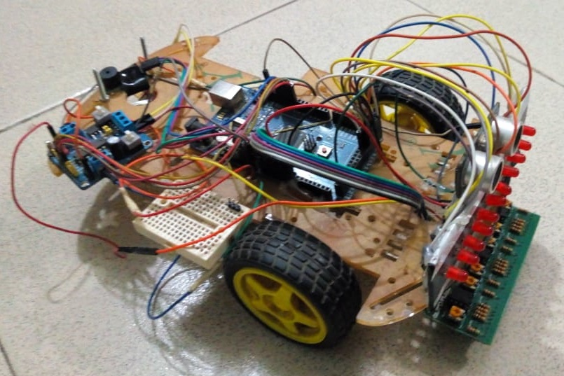

Figure 1: Line Follower Robot

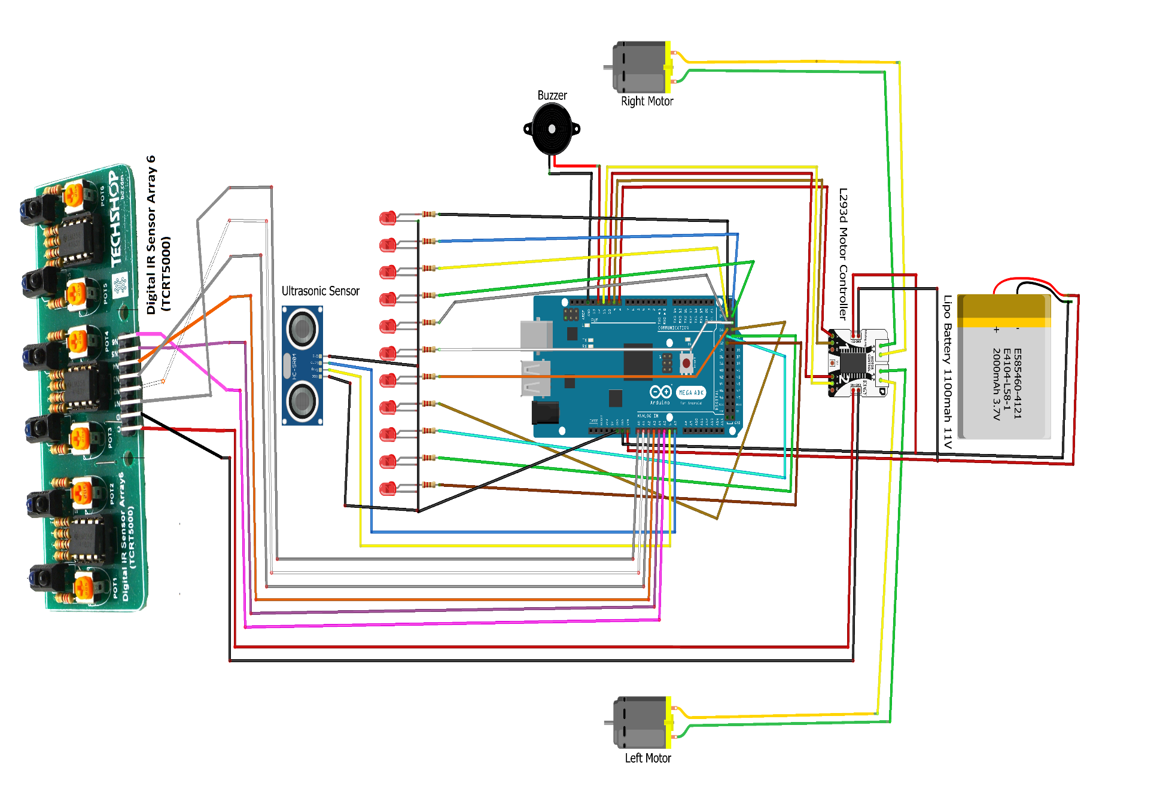

Figure 2: Line Follower Robot Circuit Diagram using Fritzing.

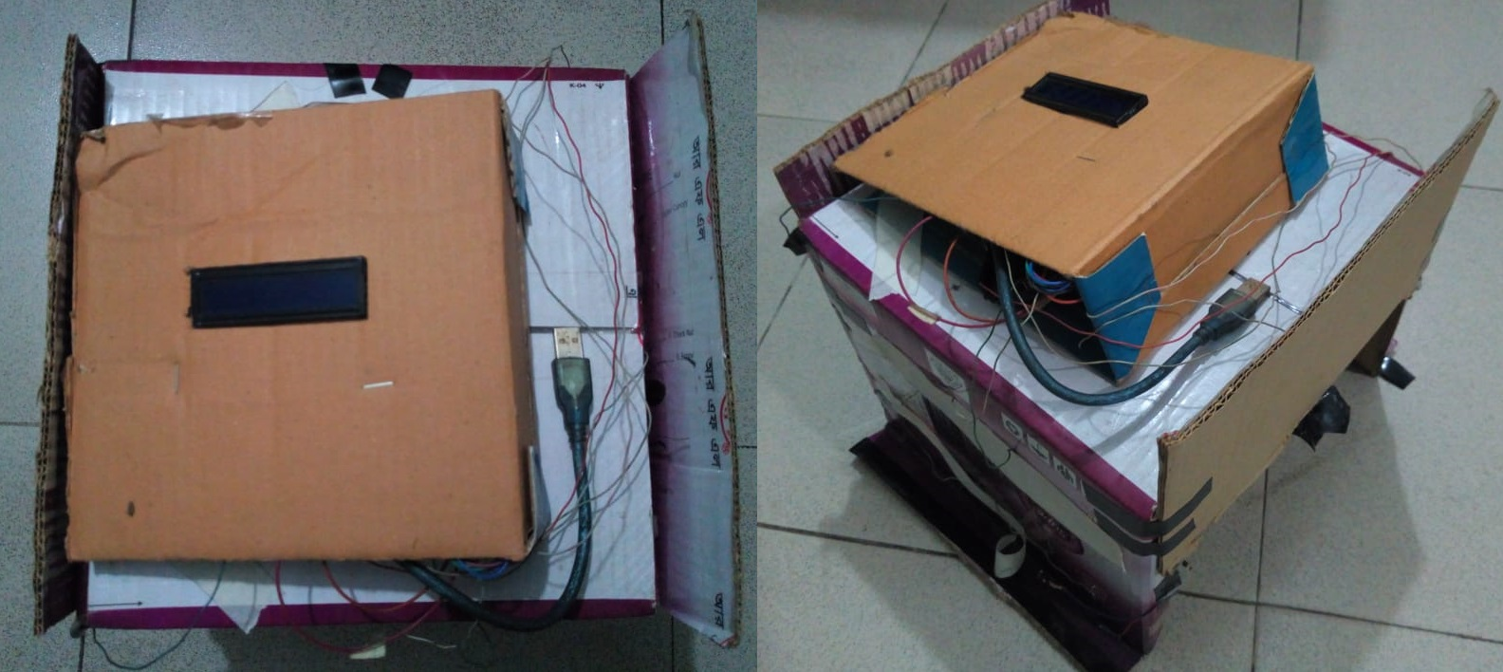

Figure 2: Cave.

**CONCLUSION (WITH POSSIBLE FUTURE WORKS)**

Our line follower robot, along with the basic features of line following, has also been embedded with several additional features. These features help to make our line follower robot more versatile and efficient. However, addition of some more features would have greatly enhanced its performance.

For our future plans regarding the project, we intend to implement the features that could not be implemented such as movement over bridge, running over white lines etc. We are also considering the addition of control by android in the line follower. Obstacle and line detection by camera is another planned feature. Also, there are plans to include an advanced cave movement mode for the robot where the cave need not be illuminated and the robot can move through the cave using sensors and its own light source to detect cave walls and move accordingly.